# Problem 3 – Evacuation

You are given a **building plan** of a school. A school is considered **safe** if during a fire students from every room can evacuate within a given **time T**. You task is to determine if the school is safe.

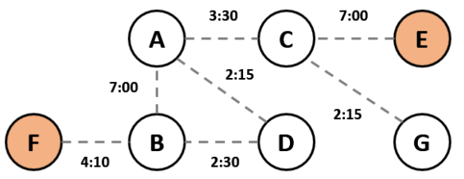

*Sample school building plan*

In the example above, we are given the time it takes to **go from one room to another** (e.g. from **A** to **B** it takes exactly **7 minutes**). All students must evacuate in time **T = 9** **minutes**. The **red circles** denote **exits**. Assume that the **students know the quickest way** to an exit and will always take it. We find quickest exit routes for each room:

|  |  |  |  |  |  |
| --- | --- | --- | --- | --- | --- |
| **Room** | **A** | **B** | **C** | **D** | **G** |
| **Time to Exit** | **8:55** | **4:10** | **7:00** | **6:40** | **9:15** |

**Room G** cannot be evacuated in **time T = 9** minutes**.** Therefore, the building is not safe.

**Note**: the triangular property does not hold here (e.g. the sum **A-D + B-D < A-B**.) This is simply because some doors/corridors are wider and it takes different time to go from one room to another.

#### Input

* On the first input line the **number of rooms** **N** will be given. Rooms will be numbered from **0** to **N-1**.
* On the second input line the the **exit rooms** will be given in the format "**R1 R2 … RE**".
* On the third input line the **number of connections C** between rooms will be given.
* On the next **C** lines connections will be given in the format "**RA RB T**", denoting the time it takes to go from **room A** to **room B** (applies for both directions).
* On the last line you will be given the **time** **T** in which all rooms must be evacuated.

#### Output

If all rooms can be evacuated in the given time print "**Safe**" and on a new line the room with **the longest evacuation time** (if two or more rooms have the longest evacuation time, print the one with **lowest ID**) in the   
format "**{id} ({hh:mm:ss})**"**.**

Otherwise, print "**Unsafe**" and on a new line the rooms that cannot be evacuated in time, **ordered by ID** in the format "**{id} ({hh:mm:ss}), {id} ({hh:mm:ss}), …**". The times printed should be the **shortest possible**. If a room has no access to an exit, print "**{id} (unreachable)**".

#### Constraints

* All input times will be given in the format "**mm:ss**". They will be in the range [00:01…59:59].
* All output times should be printed in the format "**hh:mm:ss**". They will not exceed **23:59:59**.
* The number of **rooms N** will be an integer number in the range [1…10000].
* The number of **exits E** will be an integer number in the range [1…100]
* Time limit: **100 ms**. Allowed memory: **16 MB**.

#### Examples

|  |  |  |
| --- | --- | --- |
| **Input** | **Output** | **Visual** |
| 7  5 4  7  1 5 04:10  2 4 07:00  6 2 02:15  0 3 02:15  1 0 07:00  1 3 02:30  2 0 03:30  09:00 | Unsafe  6 (00:09:15) |  |

|  |  |  |
| --- | --- | --- |
| **Input** | **Output** | **Visual** |
| 6  5 4  6  1 5 04:10  2 4 07:00  0 3 02:15  1 0 07:00  1 3 02:30  2 0 03:30  09:00 | Safe  0 (00:08:55) |  |

|  |  |  |
| --- | --- | --- |
| **Input** | **Output** | **Visual** |
| 5  4  5  1 2 02:30  2 3 07:30  1 3 02:15  1 4 04:30  4 3 01:15  04:00 | Unsafe  0 (unreachable), 2 (00:06:00) |  |